*Heaven’s light is our guide.*

*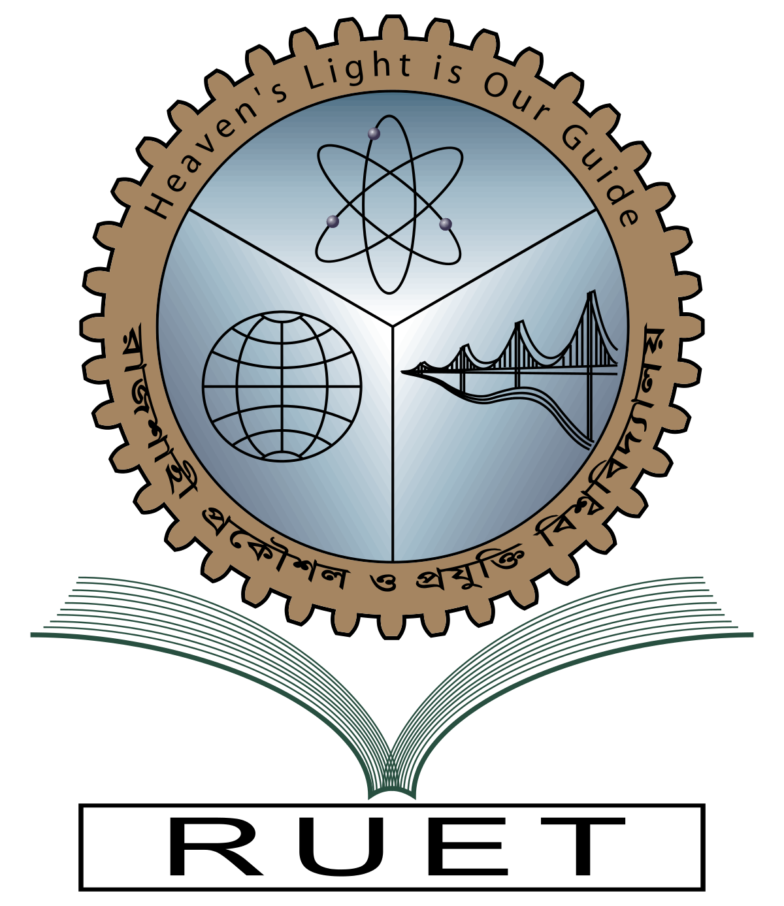***Rajshahi University of Engineering and Technology**

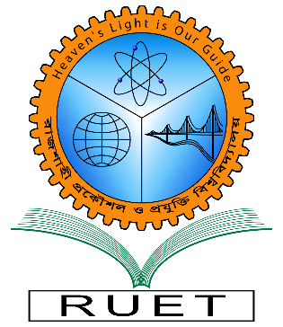

**Department of Electrical & Electronic Engineering**

**Course no.** EEE3212

**Course title:** Power Sytem I Sessional

**Experiment no.** 05

**Experiment name:** Generate an algorithm and write a program on load flow study of a given power system using Gauss-Seidel method

**Date of experiment:** October 31, 2022

**Date of submission:** November 13, 2022

|  |  |
| --- | --- |
| **Submitted to:** | **Submitted by:** |
| **Md. Nuhi-Alamin**  **Lecturer**  Dept. of Electrical & Electronic Engineering,  Rajshahi University of Engineering and Technology. | **Ashraf Al- Khalique**  **Roll:** 1801171  **Session:** 2018-2019  Dept. of Electrical & Electronic Engineering,  Rajshahi University of Engineering and Technology. |